 **GROCERY STORE APPLICATION**

**A PROJECT REPORT**

***Submitted by***

**KANIMOZHI.P (413021104015)**

**SAGAYA JENIFER.S (413021104032)**

**SWATHI.S (413021104041)**

**UMAYAL.R (413021104043)**

***In partial fulfillment for the award of the degree***

***of***

**BACHELOR OF ENGINEERING**

**in**

**COMPUTER SCIENCE AND ENGINEERING**

**ANNAI VEILANKANNI’S COLLEGE OF ENGINEERING**

**ANNA UNIVERSITY: CHENNAI 600025**

**NOV 2024**

**ANNA UNIVERSITY: CHENNAI 600025**

**BONAFIDE CERTIFICATE**

Certified that this project report **“GROCERY STORE APPLICATION”**is the Bonafide work of **KANIMOZHI.P(413021104015),SAGAYA JENIFER.S (413021104032),SWATHI.S(413021104041),UMAYAL.R(413021104043)** who carried out the project work under my supervision.

**SIGNATURE SIGNATURE**

**HEAD OF THE DEPARTMENT SUPERVISOR**

Mrs SIVANANDHINI M.E., Mrs ABISHA M.E,

Head Of the Department Assistant Professor

Department of CSE Department of CSE

Annai Veilankanni’s College Annai Veilankanni’s College

of Engineering of Engineering

Chennai – 600 127. Chennai – 600 127.

Submitted for the project work viva voice examination held on ………………

**INTERNAL EXAMINER EXTERNAL EXAMINER**

**GROCERY APPLICATION USING SPRINGBOOT**

**JAVA FULL STACK DEVELOPMENT**

**A  PROJECT REPORT**

Submitted By

**KANIMOZHI.P (413021104015)**

**SAGAYA JENIFER.S (413021104032)**

**SWATHI.S (413021104041)**

**UMAYAL.R (413021104043)**

*In partial fulfillment for the award of the degree*

*Of*

**BACHELOR OF ENGINEERING**

**IN**

**COMPUTER SCIENCE AND ENGINEERING**

**ANNAI VEILANKANNI’S COLLEGE OF ENGINEERING**

**ANNA UNIVERSITY: CHENNAI 600025**

**NOV 2024**

Full Stack Development with MERN

**GROCERY STORE APPLICATION**

1.Introduction

* **Project Title:Grocery store app**
* **Team Members:**

1.KANIMOZHI.P (413021104015)

2.SAGAYA JENIFER.S (413021104032)

3.SWATHI.S (413021104041)

4.UMAYAL.R (413021104043)

The rapid growth of online shopping has made **Grocery eCommerce** platforms critical for modern businesses. These platforms offer a convenient way for consumers to purchase products and services from the comfort of their homes. For businesses, Grocery eCommerce platforms provide an opportunity to expand their market reach beyond geographical boundaries. However, developing a robust and scalable Grocery eCommerce application requires careful planning and the right technology stack.

**2.Objective:**

The primary objective of this project is to develop a full-fledged Grocery eCommerce platform using Spring Boot. The application aims to offer a user-friendly interface for customers, secure payment processing, and robust backend management tools for administrators. By leveraging the capabilities of Spring Boot, the application will be designed to handle high traffic volumes and provide a seamless user experience.

**3.ARCHITECTURE:**

### User Management

**Authentication and Authorization:**

User management is a critical component of any Grocery eCommerce platform. The application will implement secure user registration and login mechanisms using Spring Security. This will involve setting up authentication and authorization protocols to ensure that only authorized users can access specific functionalities. Users will be able to register with their email addresses, create passwords, and receive verification emails to confirm their accounts. Multi-factor authentication (MFA) will be implemented to enhance security.

**4. System Requirements:**

Hardware Requirements:

* Processor: Intel i3 or higher
* RAM: Minimum 4GB
* Storage: Minimum 250GB

Software Requirements:

* Operating System: Windows 10 / Linux / macOS
* Web Browser: Chrome, Firefox, or Safari
* Programming Languages: HTML, CSS, JavaScript, PHP, or Python
* Database: MySQL or PostgreSQL
* Framework: Bootstrap, Django, or Laravel (depending on tech stack)

### **Product Catalog:**

**Product Listing:**

The product catalog is the heart of the Grocery eCommerce application. It will feature a dynamic display of products with search and filter capabilities. The product listing page will allow users to browse through various categories, view product images, and read brief descriptions. Advanced search functionality will enable users to find products based on keywords, price range, brand, and other attributes. Filtering options will allow users to narrow down their search results based on specific criteria.

**Product Details:**

Each product listed in the catalog will have a detailed view page. This page will provide comprehensive information about the product, including high-quality images, detailed descriptions, specifications, and customer reviews. Users will be able to see the availability status and shipping options for each product. The detailed view page will also include a section for related products, encouraging users to explore similar items.

### **Reviews and Ratings**

**User Reviews:**

Allowing customers to leave reviews and ratings for products is an important feature for any Grocery eCommerce platform. User reviews provide valuable feedback to both other customers and the business. The application will include a review system where customers can rate products on a scale of 1 to 5 stars and leave detailed comments. Reviews will be moderated to ensure that they comply with guidelines and are relevant to the product.

### **TECHNOLOGY STACK**

**Backend:**

The backend of the Grocery eCommerce application will be built using Spring Boot. Spring Boot provides a robust and scalable framework for developing Java-based applications. It offers a wide range of features, including dependency injection, security, data access, and RESTful web services. Using Spring Boot will enable the development team to build a modular and maintainable application.

**Frontend:**

The frontend of the application will be developed using Thymeleaf, a modern server-side template engine for web applications. Thymeleaf integrates seamlessly with Spring Boot and allows for the creation of dynamic web pages. HTML, CSS, and JavaScript will be used to build a responsive and user-friendly interface. The application will ensure that it provides a consistent experience across different devices and screen sizes.

**Database:**

The application will use a relational database management system (RDBMS) such as MySQL or PostgreSQL. Spring Data JPA will be used to manage database interactions, providing a high-level abstraction for CRUD operations. The database schema will be designed to handle the complexity of Grocery eCommerce data, including user accounts, product information, orders, and reviews.

CODING:

**CLIENT:**

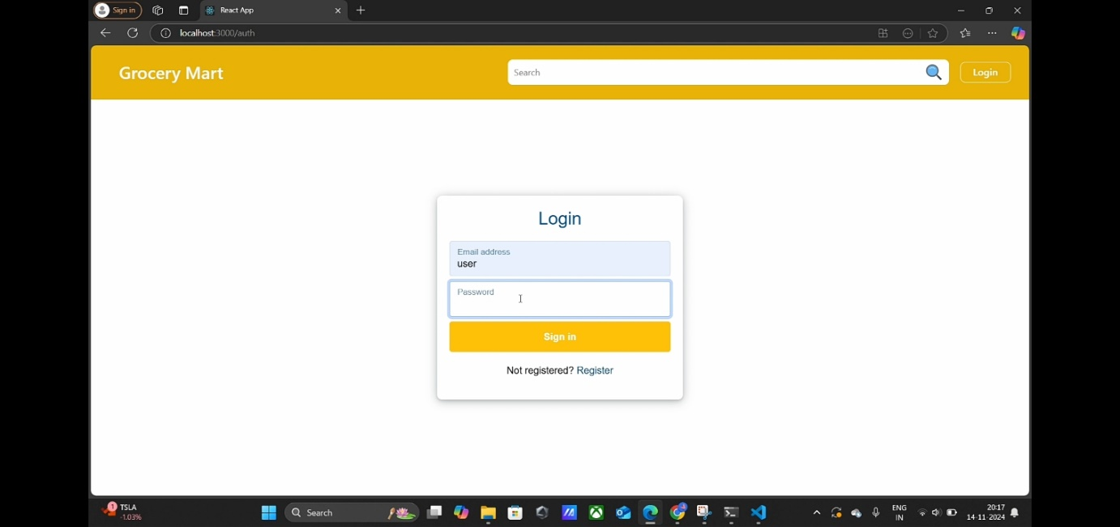

**SERVER:**

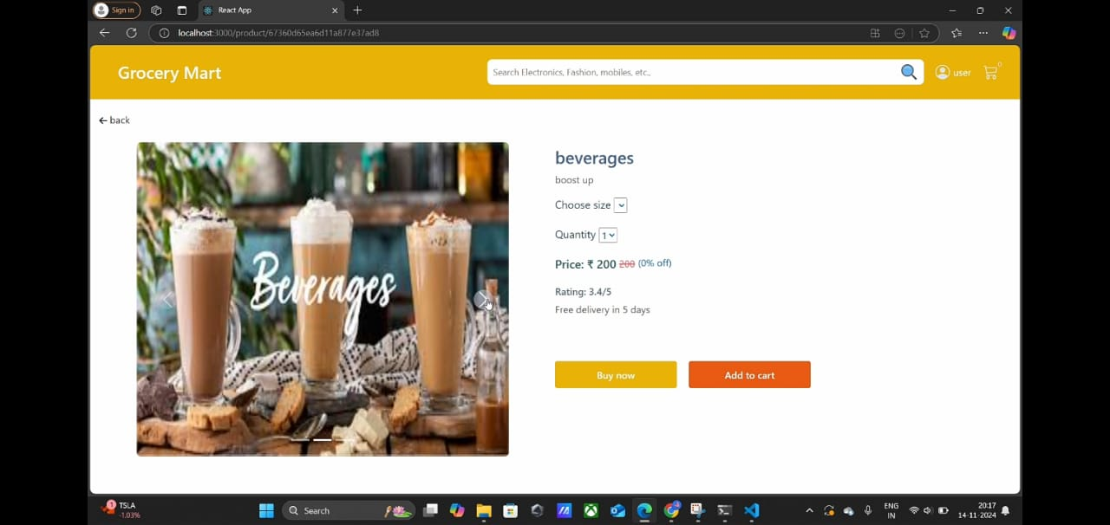

**IMPLEMENTATION:**

The implementation of the Grocery eCommerce application using Spring Boot involves several critical steps, each contributing to the development of a robust, scalable, and user-friendly platform. The first step in this process is setting up the project environment. This begins with the creation of a new Spring Boot project using the Spring Initializr, where we select the necessary dependencies such as Spring Web, Spring Data JPA, Spring Security, Thymeleaf, and the appropriate database connector. The project is then configured by defining essential parameters in the application.properties file, such as database connection details, server port, and security settings. This configuration ensures that the application can interact seamlessly with the database and other required services.

### **CONCLUSION:**

This Grocery eCommerce application built with Spring Boot aims to deliver a reliable, scalable, and secure platform that meets the needs of both consumers and administrators. By leveraging modern technologies and best practices, the application promises to enhance the online shopping experience and streamline backend management. The project will ultimately contribute to the growth and success of online retail businesses by providing a comprehensive solution for Grocery eCommerce operations.